📄 Cybersecurity Project Report

Sentient Shield – SOC & EDR Grid Deployment

Project Title:
Sentient Shield – Enterprise SOC & EDR Grid Deployment
Author: Mayank
Duration: Feb 21 – Feb 27
Environment: Virtual Lab
Tools Used:
- Wazuh (SIEM / XDR)
- OpenSearch
- Ubuntu Server 22.04
- Windows Endpoint
- VirtualBox
- Sysmon
- Hydra (Attack simulation)

Executive Summary
This project implements a lightweight Security Operations Center (SOC) using Wazuh SIEM to monitor endpoint activity, detect threats, and visualize alerts. The lab environment consists of an Ubuntu-based Wazuh Manager and a Windows endpoint integrated via Wazuh Agent. Detection capabilities include log monitoring, file integrity monitoring, brute-force detection, and MITRE ATT&CK mapping. The system demonstrates the detection-analysis-response workflow used in enterprise SOC operations.

Project Objective
Goal:
Build a centralized SOC capable of:
- Endpoint monitoring
- Threat detection
- Alert visualization
- Automated response
Expected Outcome
- Windows endpoint integrated with Wazuh
- Logs flowing into dashboard
- Detection of suspicious activity
- Security events mapped to MITRE ATT&CK

Lab Architecture

Infrastructure Layout

System | Role
Kali Linux | Attacker machine
Ubuntu Server | Wazuh Manager
Windows VM | Endpoint monitored

Architecture Diagram :

Attacker (Kali)
↓
Windows Endpoint
↓
Wazuh Agent
↓
Wazuh Manager
↓
OpenSearch Indexer
↓
Dashboard

Environment Setup

Virtual Machine Configuration

Ubuntu Wazuh Manager

Setting | Value
RAM | 4GB
CPU | 2 cores
Disk | 40GB
Network | Bridged  Adapter

Week 1 – Infrastructure Deployment

Step 1 – Install Ubuntu Server
Command:
sudo apt update && sudo apt upgrade -y
Purpose:
Update system packages before installing security stack.
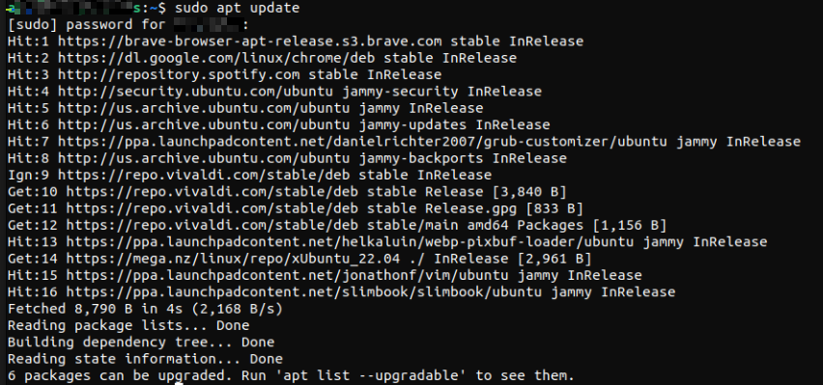

Step 2 – Install Wazuh
Command:
curl -sO https://packages.wazuh.com/4.7/wazuh-install.sh
sudo bash wazuh-install.sh -a

Result:


- Wazuh Manager installed
- OpenSearch indexer configured
- Dashboard initialized

Step 3 – Access Wazuh Dashboard
Open browser:
https://<192.168.31.65>

Login using admin credentials:

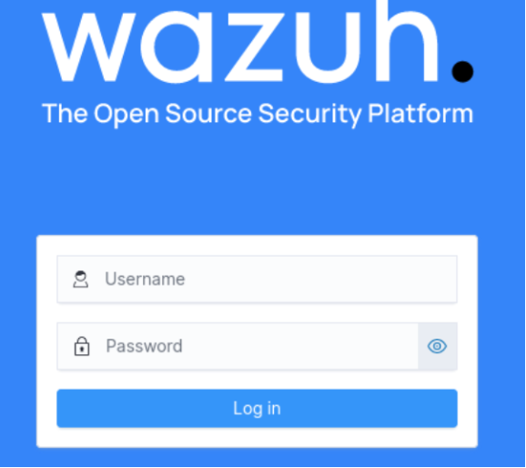

Wazuh dashboard
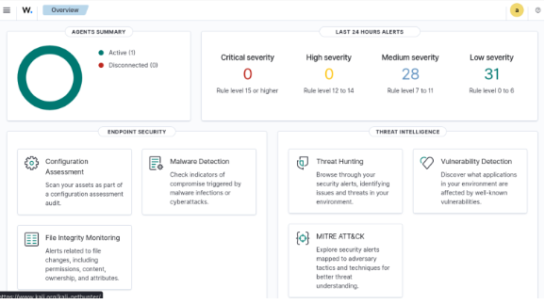

Week 2 – Endpoint Integration

Step 1 – Create Windows VM
Install Windows OS and confirm network connectivity.
Test:
ping 192.168.31.65
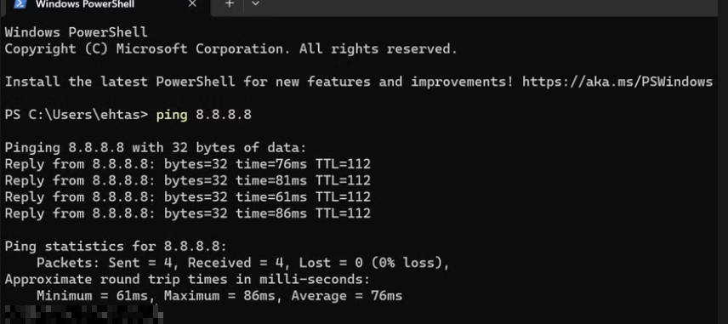

Step 2 – Install Wazuh Agent
Command (Command Prompt):
Powershell https://packages.wazuh.com/4.x/windows/wazuh-agent.msi -OutFile agent.msi
Install agent:
msiexec /i agent.msi /q WAZUH_MANAGER="192.168.31.65"
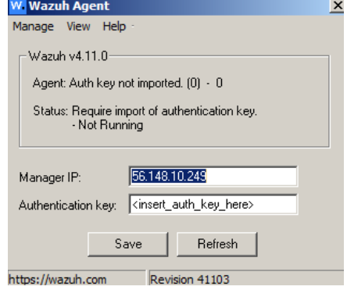
Start service:
net start wazuh

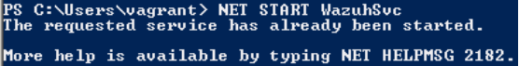

Step 3 – Register Agent
On Ubuntu:
sudo /var/ossec/bin/manage_agents
Add agent and extract authentication key.


Step 4 – Verify Agent Status
Command:
sudo /var/ossec/bin/agent_control -l
output:
ID: 001 | Name: Wazuh_Endpoint | Status: Active

Week 3 – Detection Engineering

File Integrity Monitoring

Monitor sensitive directories.

Example configuration:

<syscheck>

<directories check_all="yes">C:\Users</directories>

</syscheck>

Purpose:

Detect unauthorized file modifications.

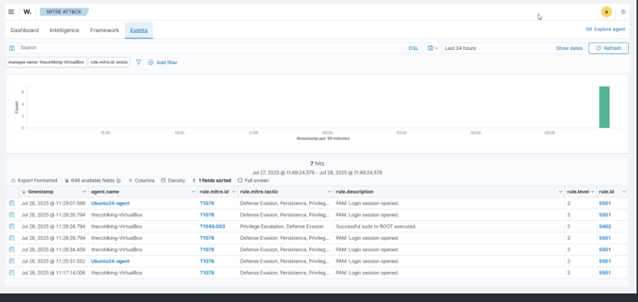

Brute Force Detection

Attack simulation from Kali:

hydra -l administrator -P rockyou.txt rdp://<target-ip>

Result:

Multiple login failures detected.

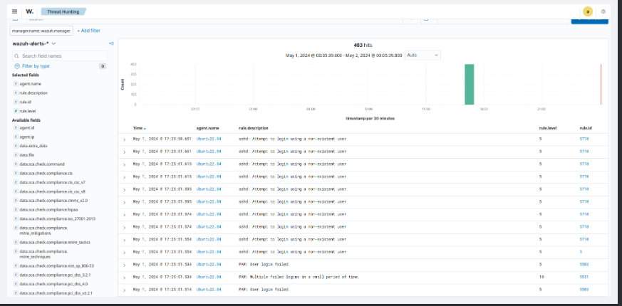

Multiple Login attempts of failed attempts suggests some one has tried to brute force login to gain excess and we are able to detect via anomaly.

Week 4 – Threat Simulation

MITRE ATT&CK Mapping
Security events mapped to attacker techniques.
Example:
Attack | MITRE Technique
Brute Force | T1110
Credential Access | T1003
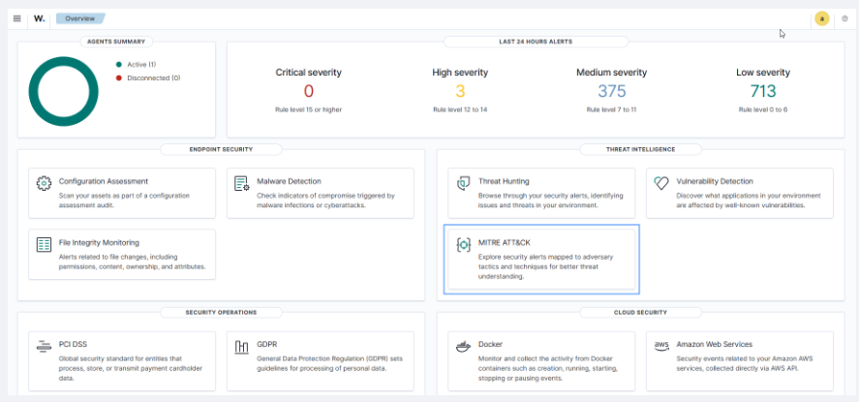

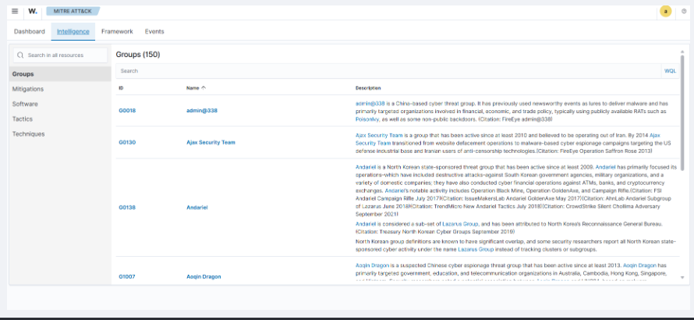

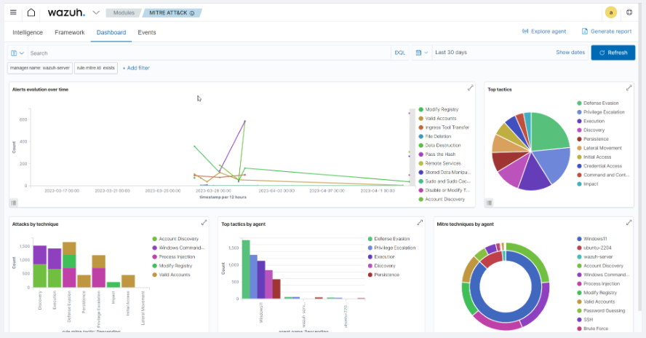

Security Event Workflow
Detection logic:
Log Generated
↓
Wazuh Agent
↓
Wazuh Manager
↓
Rule Matching
↓
MITRE Mapping
↓
Alert Created
↓
Dashboard Visualization

Key Learnings
- Practical SOC architecture
- Endpoint telemetry collection
- SIEM deployment
- Threat detection workflow
- Attack simulation techniques

Challenges & Troubleshooting
Issue | Solution
Agent not connecting | Verified firewall and manager IP
Authentication errors | Re-generated agent key
IP change issue | Updated manager addres

Conclusion
The project successfully demonstrated the deployment of a lightweight SOC infrastructure using Wazuh SIEM. The system was capable of collecting endpoint logs, detecting suspicious behavior, and visualizing alerts through a centralized dashboard. This setup replicates the detection used in real-world security operations centers.

